
DEPARTMENT OF CSE
PROJECT ABSTRACT SUBMISSION
COURSE: SOA PROGRAMMING AND MICROSERVICES– (24SDCS03) A.Y. 2026 - 2027
TITLE OF THE PROJECT
S. No. | University ID | Name
1 | 2420030591 | L. Mrudani
2 | 2420030337 | C. Suma Priya
3 | 2420090107 | P. Hasitha
4
Name of the Guide

Abstract
The AI-Based Smart Transport Fleet Management System is a Service-Oriented Architecture (SOA)-based intelligent transportation solution designed to improve the efficiency, reliability, and utilization of vehicle fleets. Traditional fleet management systems mainly focus on vehicle tracking, driver management, trip scheduling, fuel monitoring, and maintenance record management. However, they often rely on manual decision-making and respond to problems only after they occur.
The proposed system integrates Artificial Intelligence and Machine Learning with independent SOA-based services to provide intelligent fleet management. The system manages vehicles, drivers, trips, maintenance, and routes through separate services that communicate through APIs. Machine learning techniques are used for predictive maintenance, fuel-consumption prediction, vehicle allocation, and travel-time/route prediction. Based on vehicle condition, availability, fuel efficiency, trip requirements, and predicted maintenance risks, the system recommends the most suitable vehicle and route for a particular trip. The system can also identify vehicles that may require maintenance before a potential breakdown occurs, thereby reducing downtime and operational costs.
The major advantage of the proposed system is that it goes beyond basic fleet monitoring by providing AI-assisted decision-making and predictive optimization. The modular SOA architecture allows individual services to be developed, deployed, and scaled independently, making the system suitable for real-world transport organizations. The proposed solution aims to reduce fuel consumption, improve vehicle utilization, minimize unexpected breakdowns, optimize transportation operations, and enhance overall fleet efficiency.

Flow Diagram:

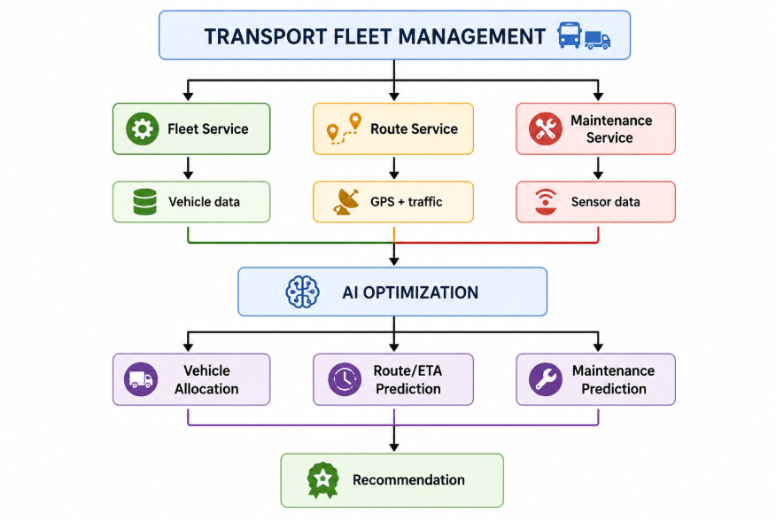

Project Architecture/Project Overview:

